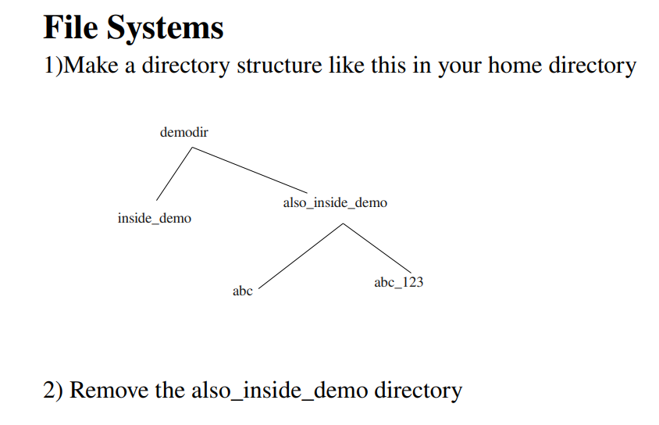

ANSWER:

1: $mkdir demodir

$cd demodir

$mkdir inside_demo

$mkdir also_inside_demo

$cd also_inside_demo

$mkdir abc

$mkdir abc_123

2: $rm -rf also inside_demo